**Area of Parallelograms and Triangles**

# Introduction to Planar region and Area

The part of the plane enclosed by a simple closed figure is called a **planar region** corresponding to that figure. The magnitude or measure of that planar region is called its **area**.

# Congruent figures and their areas

* + Two figures are called **congruent**, if they have the same shape and the same size.
  + If two figures A and B are **congruent**, they must have **equal areas**.
  + Two figures having **equal areas need not be congruent**. In the figure,

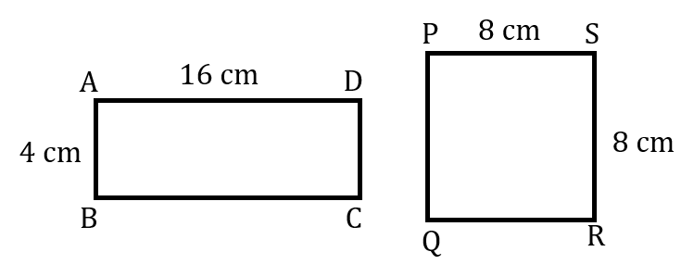

Area of rectangle ABCD = 16 × 4 = 64 cm2 Area of square PQRS = 82 = 64 cm2

Area of rectangle ABCD = Area of square PQRS

But, rectangle ABCD and square PQRS are not congruent.

# Area of a figure

Area of a figure is a number (in some unit) associated with the part of the plane enclosed by the figure.

# Area of the planar region

If a planar region formed by a figure *T* is made up of two non-overlapping planar regions formed by figures P and *Q*, then ar(*T*) = ar(*P*) + ar(*Q*).

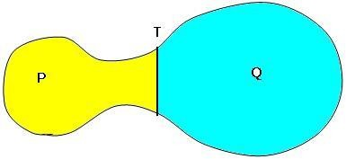

# Figure on the same base and between the same parallels

* + Two figures are said to be on the same base and between the same parallels, if they have a common base (side) and the vertices (or the vertex) opposite to the common base of each figure lie on a line parallel to the base.

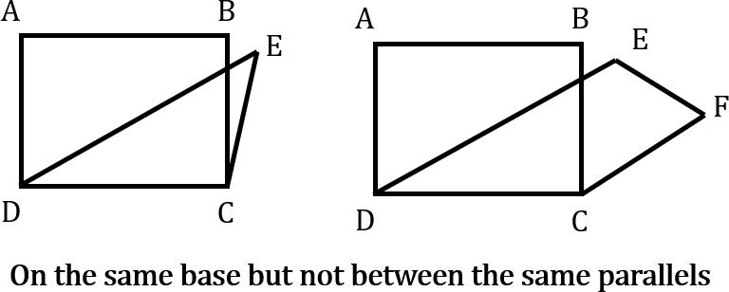

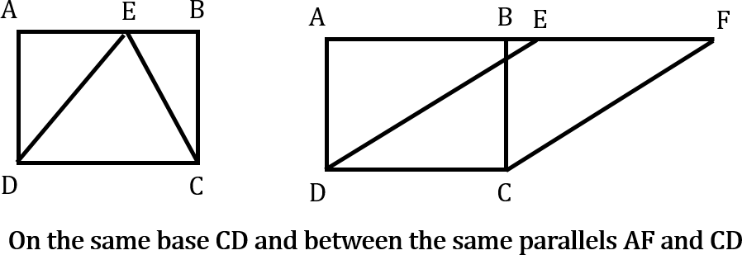

* + Please note that out of the two parallels, one must be the line containing the common base.

# Areas of figures on the same base and between the same parallels

* + Parallelograms on the same base and between the same parallels are equal in area.

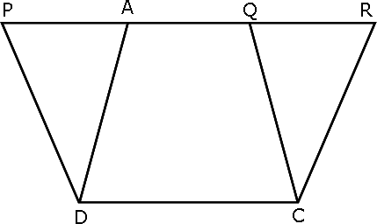

In the figure, parallelograms PQCD and ARCD lie on the same base CD and between same parallels CD and PR. So, ar(PQCD) = ar(ARCD).

* + **Area of a parallelogram** is the product of its any side and the corresponding altitude.
  + Parallelograms on the same base (or equal bases) and having equal areas lie between the same parallels.
  + If a triangle and a parallelogram are on the same base and between the same parallels, then the area of the triangle is equal to half of the area of the parallelogram.

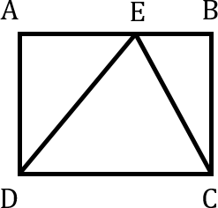

In the figure, triangle DEC and parallelogram ABCD are on the same CD and between the same parallels AB and CD.

Therefore, area of triangle DEC = ½ × area of parallelogram ABCD.

* + 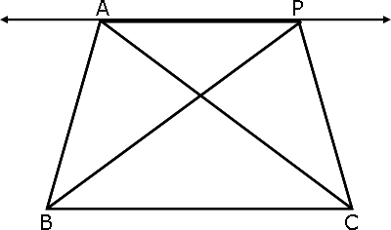Two triangles on the same base (or equal base) and between the same parallel are equal in area.

In the figure, triangles ABC and PBC lie on the same base BC and between same parallels BC and AP.

Therefore, ar(triangle ABC) = ar(triangle PBC).

* + **Area of a triangle** is half the product of its base (or any side) and the corresponding altitude (or height).

# Important facts about triangles on the same base

* + Two triangles with same base (or equal bases) and equal areas will have equal corresponding altitudes.
  + Two triangles having the same base (or equal bases) and equal areas lie between the same parallels.
  + A median of a triangle divides it into triangles of equal areas.